In this lesson we will learn to playing with the roto tool and masking so if we got to draw nodes in the tool list as marked below

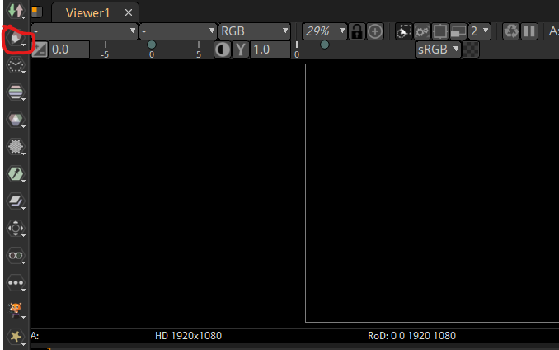

And then in submenu

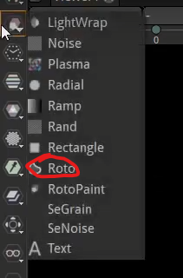

And now the node graph will be like

You can see increase the area of a panel by coming in between the panel we want to resize and the next panel end then drag it to resize that panel

Now our Node graph will look below

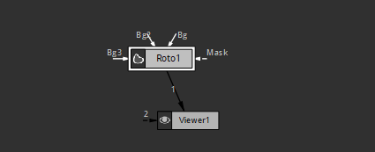

Because of Toto node you see extra tools beside the toolbar as marked below

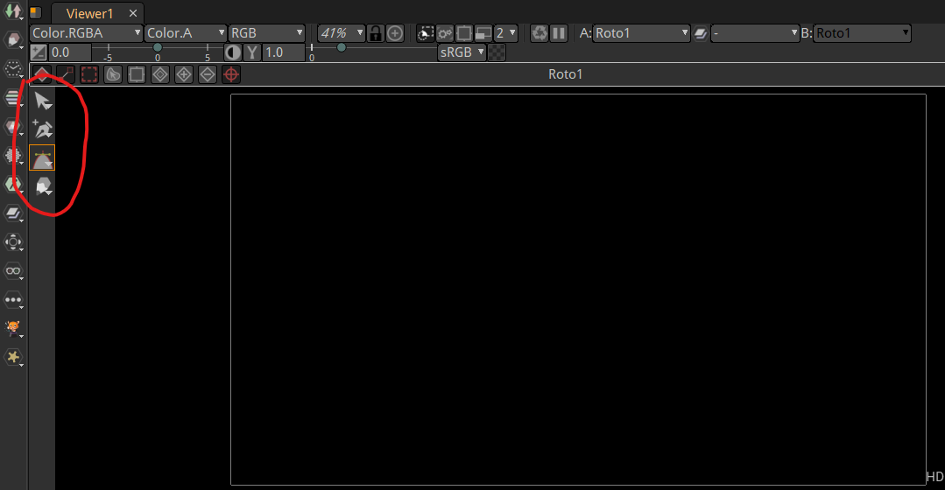

Now you can see

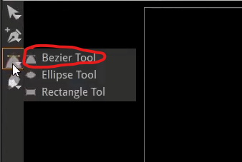

That Bezier tool is by default chosen now we go to the toolbar beside the main toolbar and then go to the menu(to open submenu right click or press alt and left click ) on the side of Bezier Tool

And now with this we can create points and points are the area where the tool was clicked So it execution will look like below

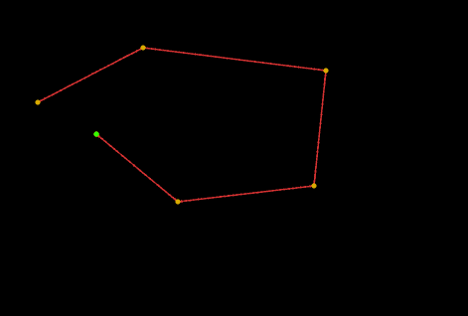

If you left click and then hold and drag then it create a curve point as shown below

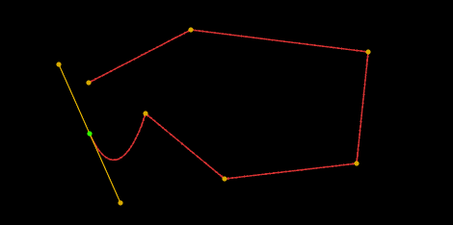

Now when we close it by clicking on the first point then we got this closed shape below

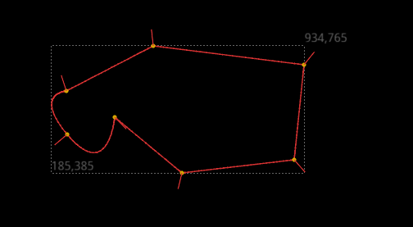

So we can move around It

But the problem I faced was that when I clicked on the last point or any other point then it will make a curve

Now we go to the properties of Roto tool

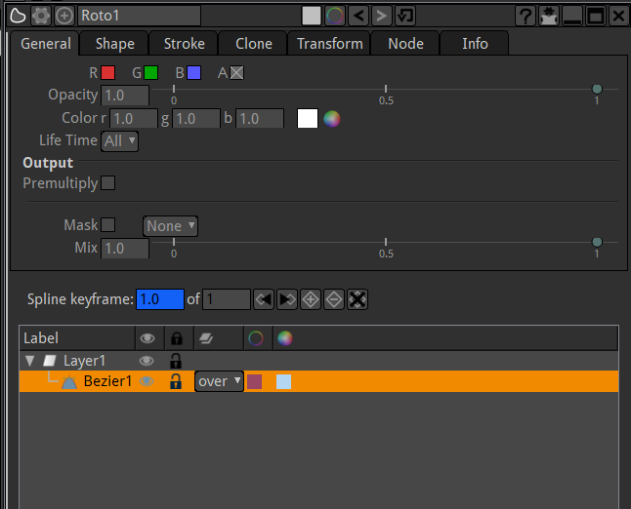

You will see that red, green and blue channel are not selected

We could have selected them and have a background color suppose I chose red then it will look like below

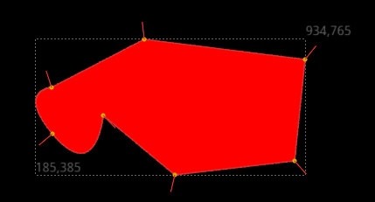

But alpha is chosen by default so its just drawing in transparency so we can see what the alpha is by seeing the alpha channel as shown below

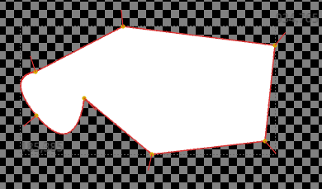

So it appears here but it’s really jus like an alpha drawn overtop of transparency

So I am gonna delete this layer so first of all lets draw another layer actually So will and then we will bring in an image and interact with this roto that we drawn(who knows). If we right click under these tools

Now we go to marked area

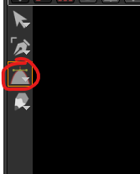

And then by alt and then click or right click a submenu will be open

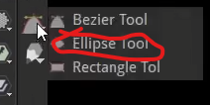

Now click on ellipse button as marked above

1:22